Milestone 3 Search
Must remove all references to Mailmanager and replace with Koyomail and the provided Icon. Branding and typeface needs to be used.

Search:
I was reviwing the program we used to base our requirements on Mail Manager. I note that there are a few things it does that I understand but it seems very wasteful. First it keeps a cache locally on the laptop/workstation of filed emails. This Cache purpose appears to be for offline searching and retrieval of filed emails. The problem is your potentially storing gigabyes of emails locally on the device just to enable this.
The search function. Does this keep an index of some sort? to index the filed emails to enable fast search or does it just search the filed email locations and email headers/contents one by one. I thiking of speed of search here over 1000’s of email how quick will this be?
In the search Settings:
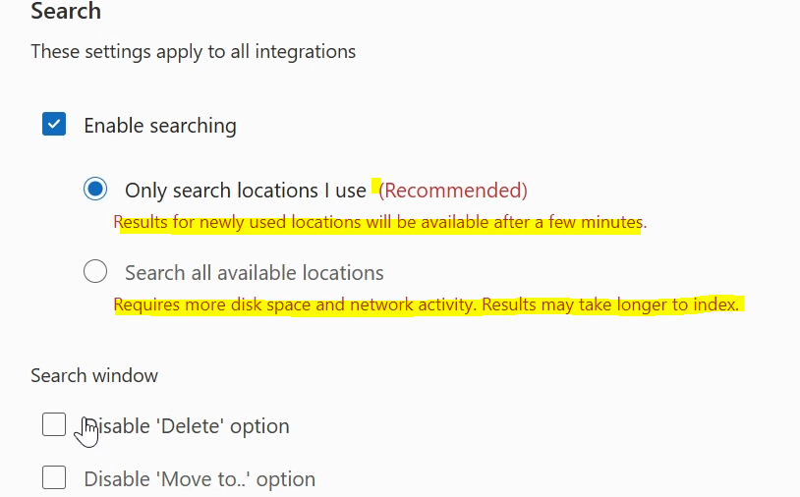

The Only search locations I use, just delete, (Recommended) and the red text, remove Results for newly used locations …
Search all avilable locations , the red text needs to read. Searches will take longer with this option.
Use the simplae format for the below.
Disable the Delete Option
Disable to Move to option

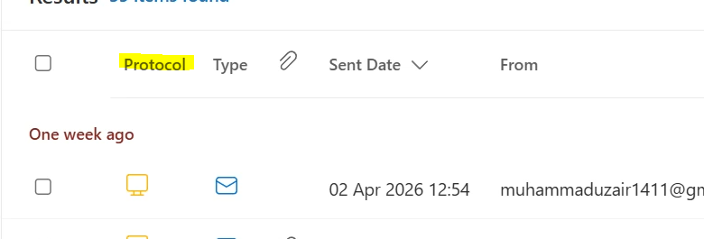

What is Protocol? In the above,

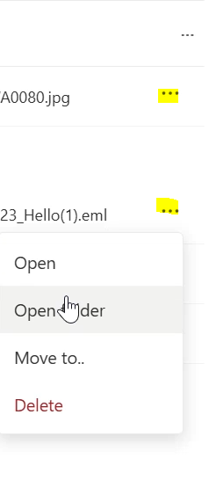
The tree dots maybe better to put this on the left hand side marked below,
